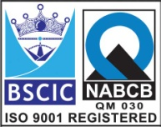****

**Basket Type Strainer**

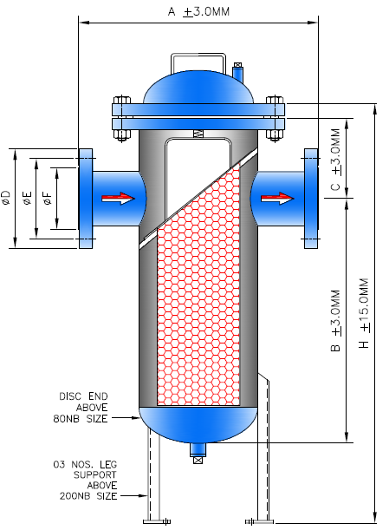

**Features: -**

* Bolted Cover Design
* Mesh Available in 2 to 200
* Pressure Rating – 150#
* End Connection – Flanged End, RF
* Flange Drilling – As per ANSI B16.5, 150#
* Face to Face – Manufacturing Std.
* Free Flow Area – 3 Time of Pipe area

**Testing Standard: - API 598**

|  |  |  |
| --- | --- | --- |
| Test Pressure in PSIG | | |
| Test | Hydrostatic | Air |
| Pr. Rating | 150# |
| Body | 450 |  |

**Part List: - Standard Dimension (150#): -**

|  |  |  |  |  |  |  |  |  |  |  |  |  |  |  |  |  |  |
| --- | --- | --- | --- | --- | --- | --- | --- | --- | --- | --- | --- | --- | --- | --- | --- | --- | --- |
| **No** | **Part Name** | **Materials** |  | **Size** | **40** | **50** | **65** | **80** | **100** | **125** | **150** | **200** | **250** | **300** | **350** | **400** | |
| **01** | Shell & Nozzle | IS 1239/3589 ERW Pipe of  IS 2062 Plate | **A** | 300 | 310 | 350 | 410 | 460 | 470 | 520 | 610 | 720 | 800 | 870 | 980 | |
| **B** | 220 | 240 | 300 | 350 | 380 | 460 | 550 | 710 | 860 | 870 | 880 | 1050 | |
| **02** | Cover & Flange | CS IS 2062 Plate | **C** | 100 | 100 | 120 | 130 | 160 | 170 | 190 | 230 | 260 | 310 | 330 | 370 | |
| **03** | Mesh / Screen | SS304 / 316 / 304L / 316L / Brass | **H** | 330 | 350 | 450 | 510 | 570 | 660 | 780 | 1230 | 1390 | 1480 | 1670 | 1820 | |
| **04** | Gasket | CAF/EPDM/Sp. Wound |  |  |  |  |  |  |  |  |  |  |  |  |  | |
| **05** | Cover Bolt & Nut | PTFE / GFT / CFT |  |  |  |  |  |  |  |  |  |  |  |  |  | |
|  |  |  |  |  |  |  |  |  |  |  |  |  |  |  |  | |
|  |  |  |  | | | | | | | | | | | | | |

**Due to continuous development Program, the design & data given in this leaflet are subject to change without prior notice.**

**ANITA ENGINEERING WORKS**



58-59, Narayan Estate, Opp. Shree Ram Estate, Nr. CMC Ltd. Odhav, Ahmedabad-382415, Gujarat, India

Phone: +91 79 22974101, Fax: +91 79 22875014

Email: eascovalves@gmail.com, eascovalves@yahoo.com, Web: [www.eascovalve.com](http://www.eascovalve.com)